**PART 0: POLKADOT-JS (Wallet setups)**

1. **Extension:** Download and install the browser extension.

1. Go to [**https://polkadot.js.org/extension/**](https://polkadot.js.org/extension/).

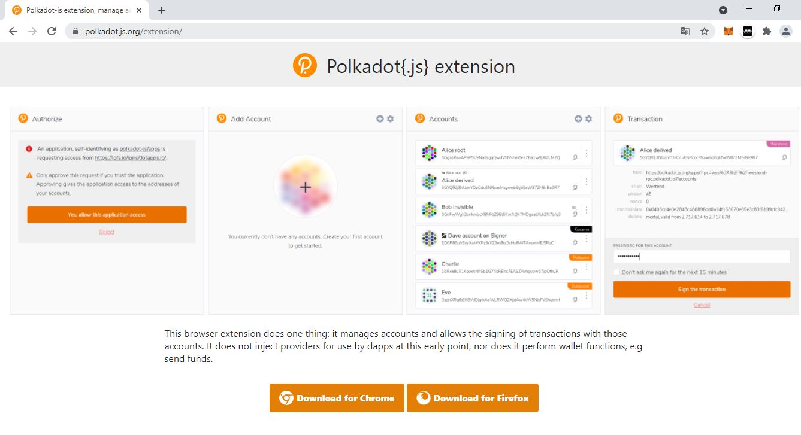

2. Click **Download for Chrome**.

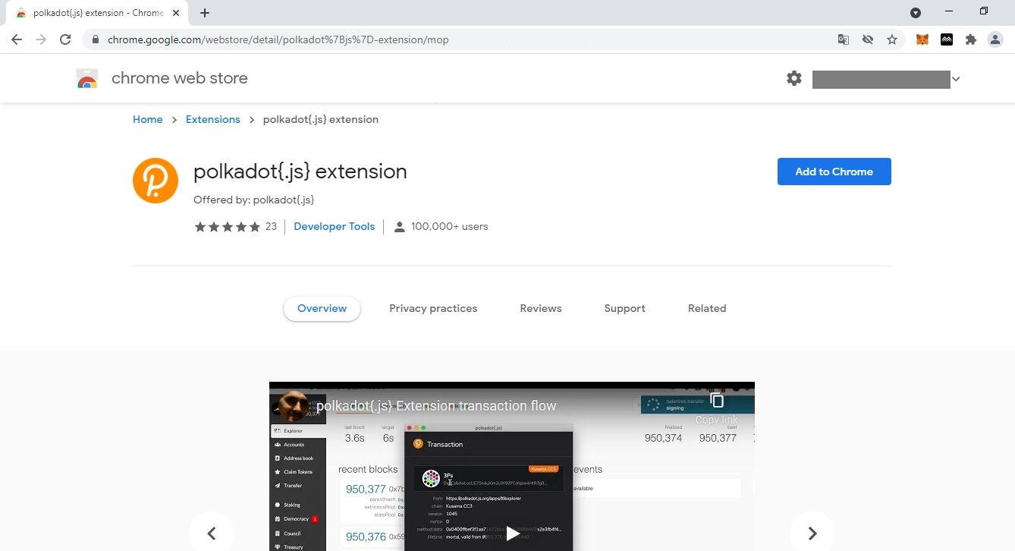

3. Click **Add to Chrome** to install the browser extension.

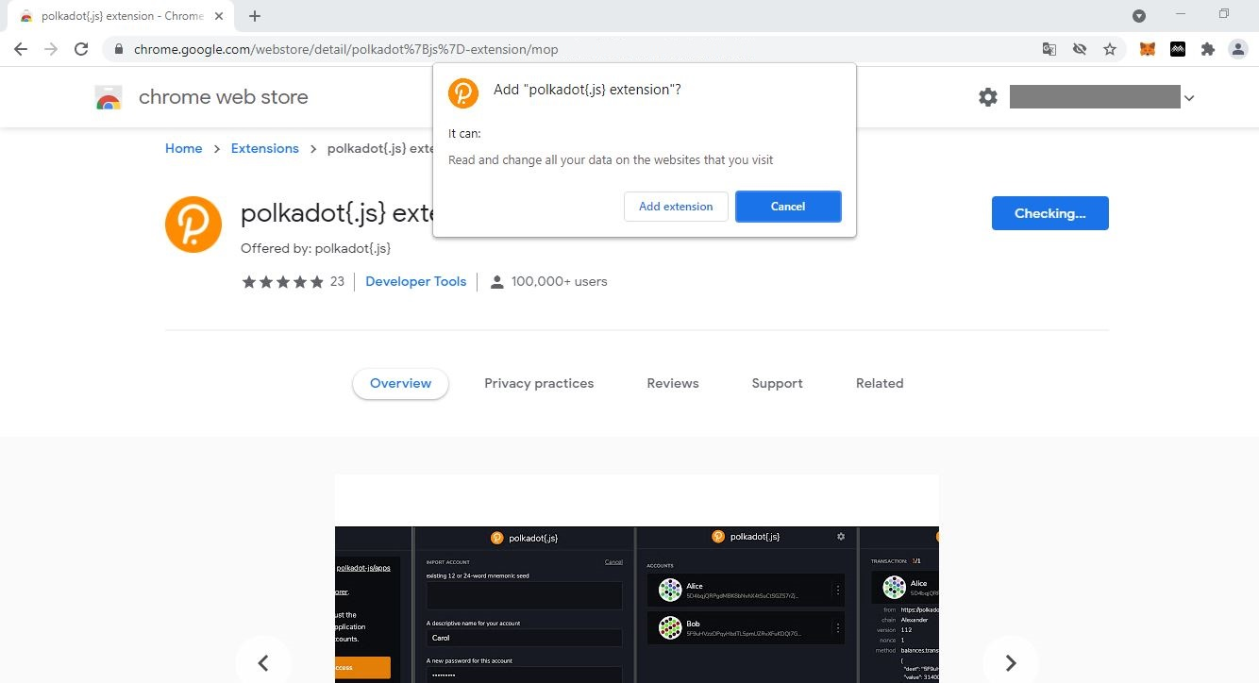

4. Click on **Add extension** to complete the procedure.

5. Click the **icon** to view the list of all installed browser extensions.

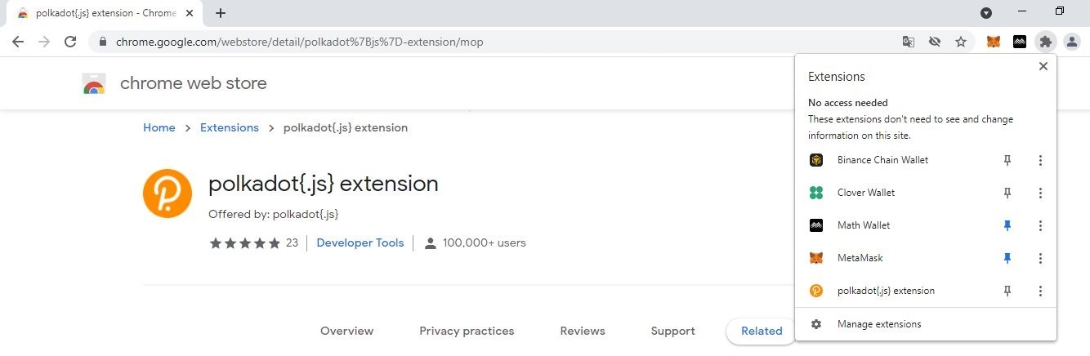

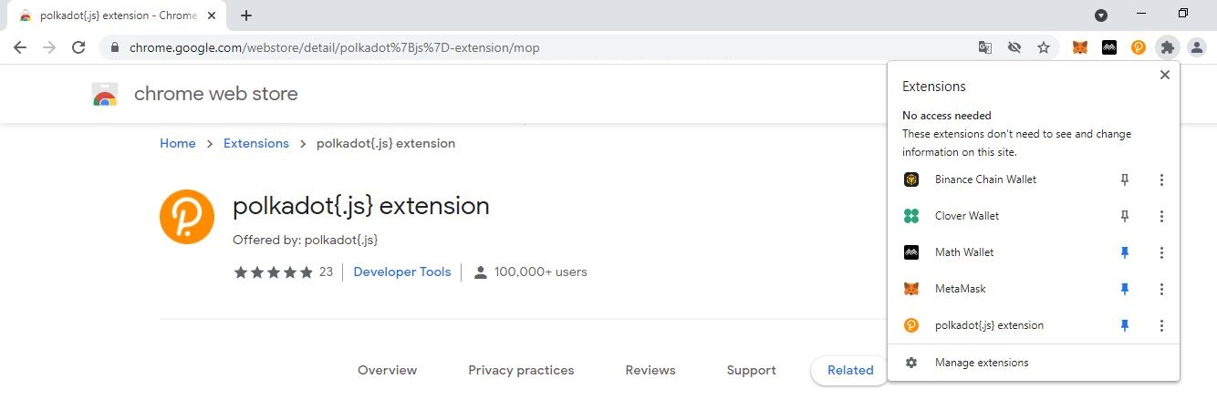

6. Click the **pin** to make the Polkadot-JS extension visible on your navigation bar.

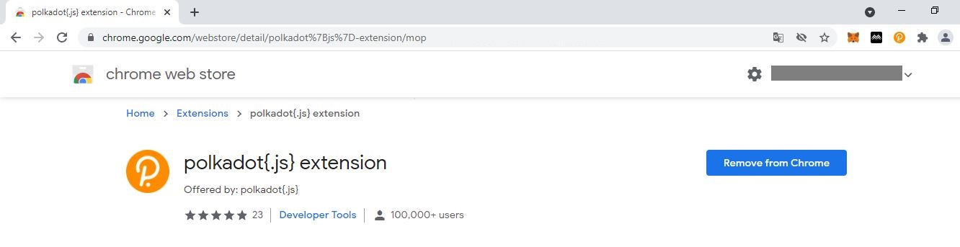

7. **The Polkadot-JS extension icon is now pinned onto your navigation bar!**

1. **Wallet:** Create a wallet from the browser extension.

1. Click on the **Polkadot-JS extension icon** to reveal the Accounts window.



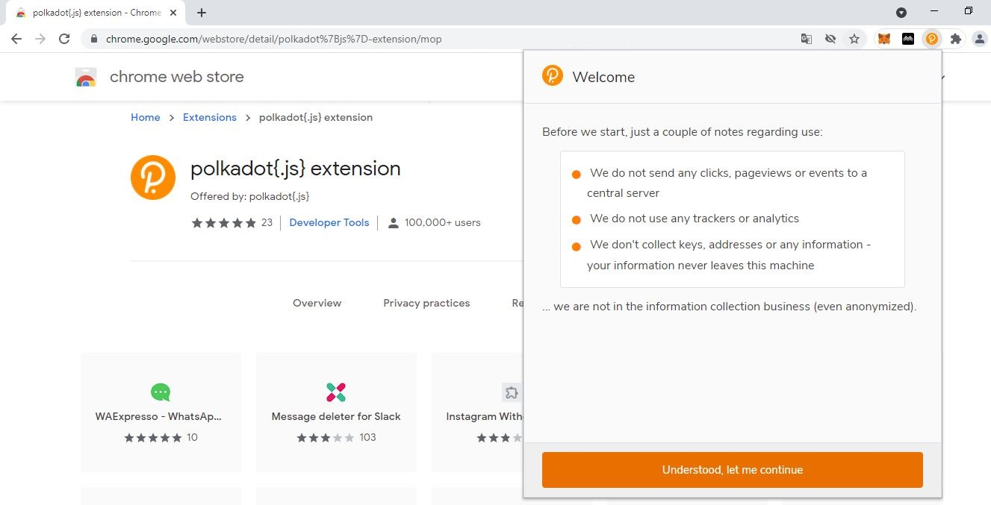

3. Click **Understood […]** to proceed.

2. Read the **notes** carefully.

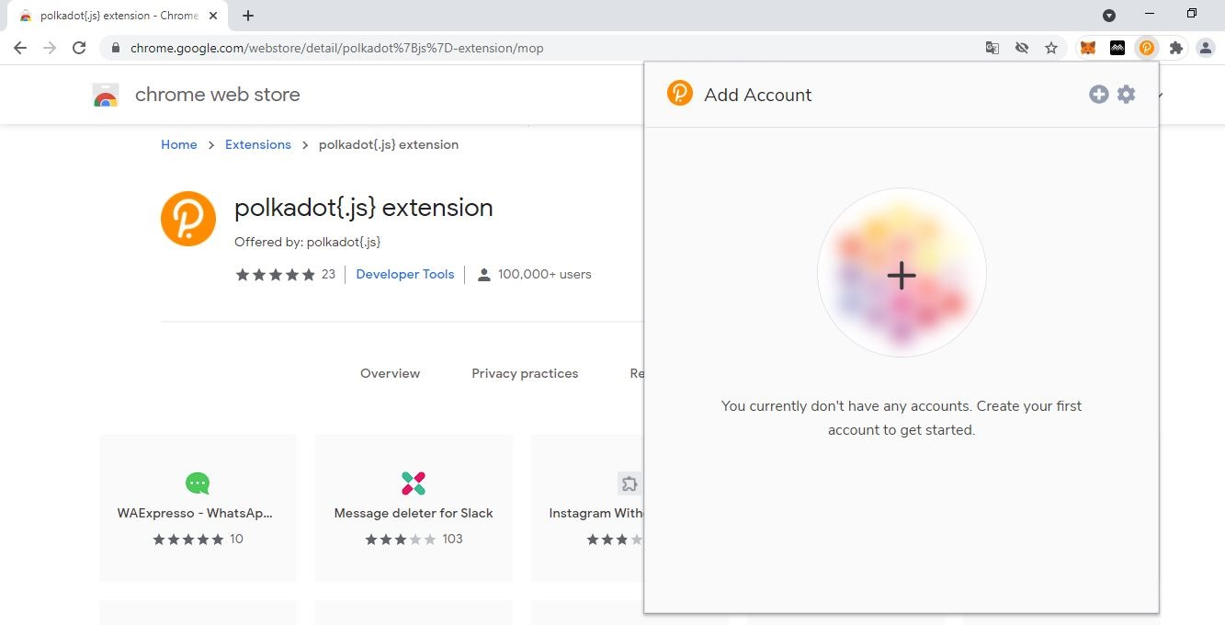

4. Click **+** to create your first account.

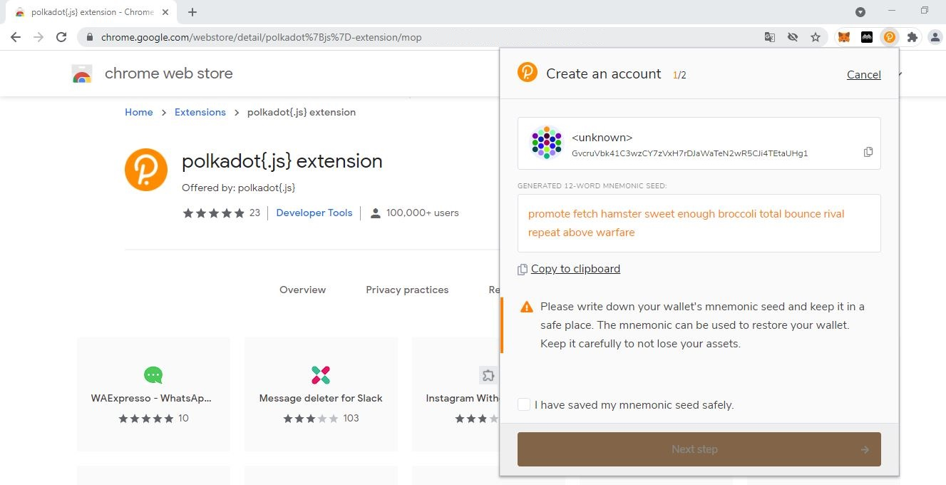

5. Make sure you **note down your seed phrase neatly** and tick the box.

**NEVER store your seed in a phone/tablet/laptop/PC!**

Write your seed in a notebook/ sketchbook or diary and keep it private.

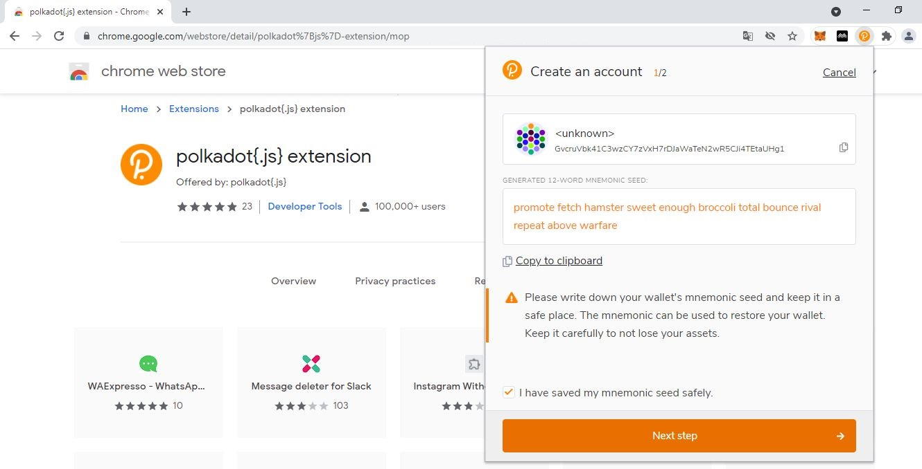

6. Click on **Next step** to continue the procedure.

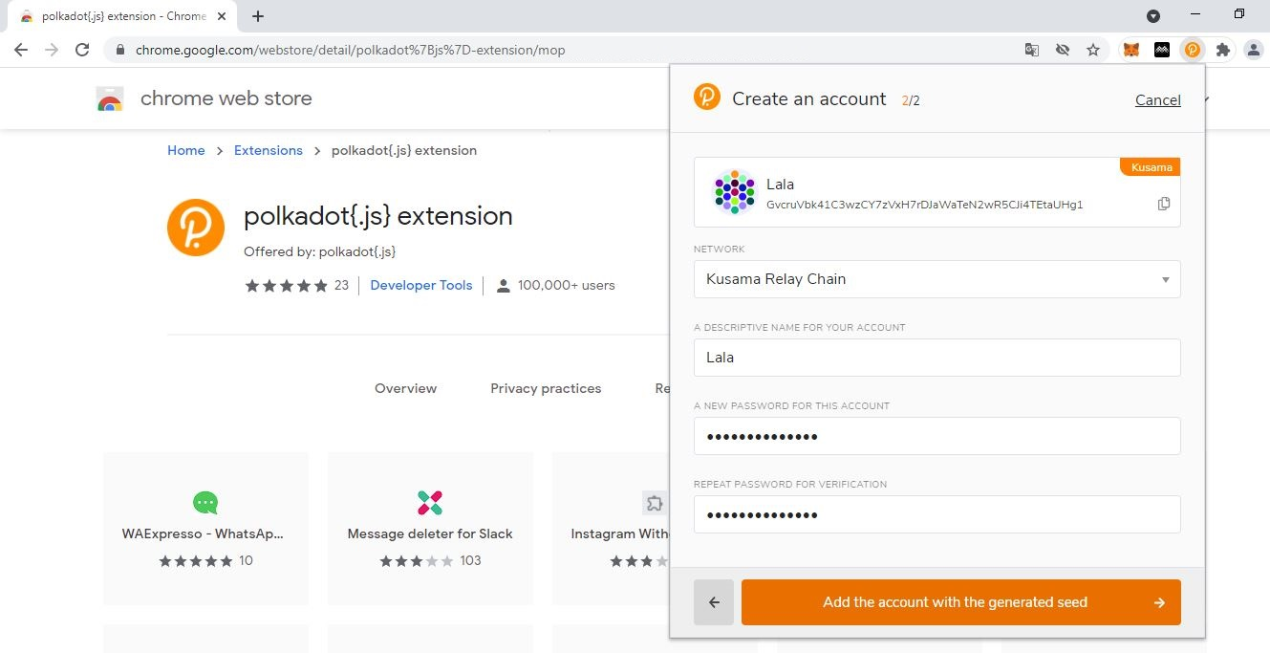

8. Click on **Add the account […]** to complete the procedure.

7. Provide the **required information.**

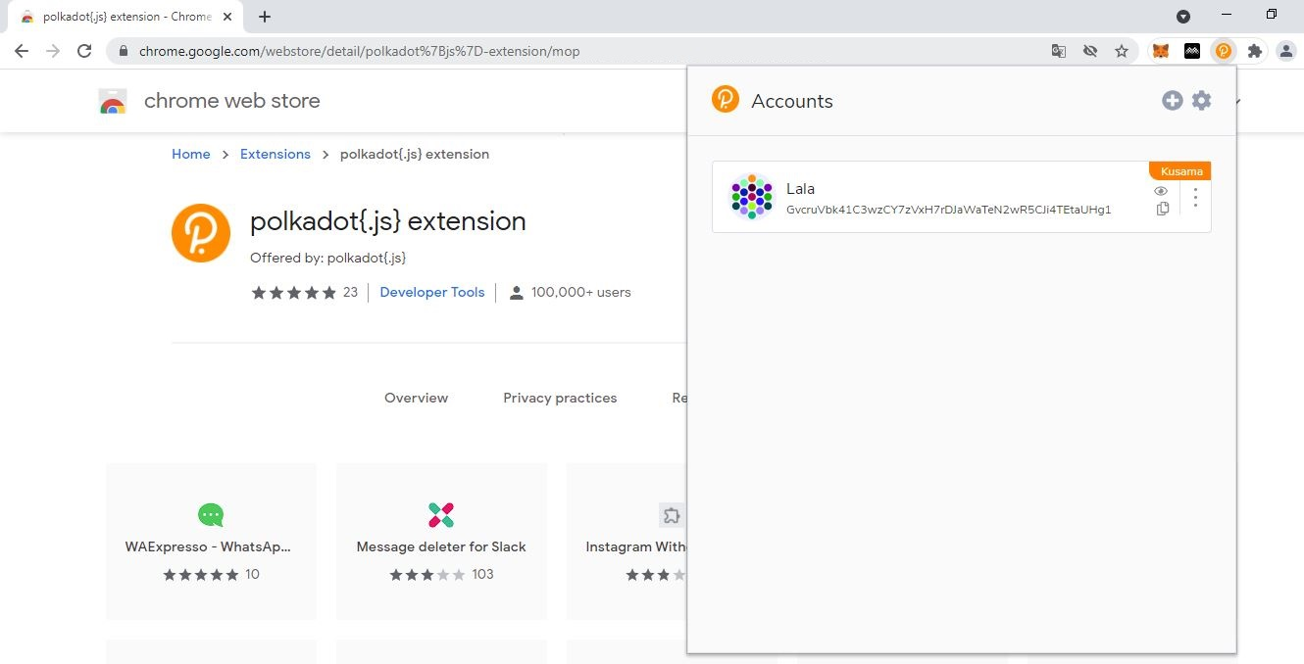

Account **address** for *Polkadot-JS Apps* operations.

Note: This cannot be changed.

Account **network** on which *Polkadot-JS Apps* operations are enabled.

Note: This can be changed later.

Account **name** for *Polkadot-JS Apps* operations.

Note: This can be changed later.

9. **Your first Polkadot-JS wallet account has been created!** procedure.

1. **Settings:** Manage browser extension settings.

1. Click the **icon** to open the Polkadot-JS extension settings.

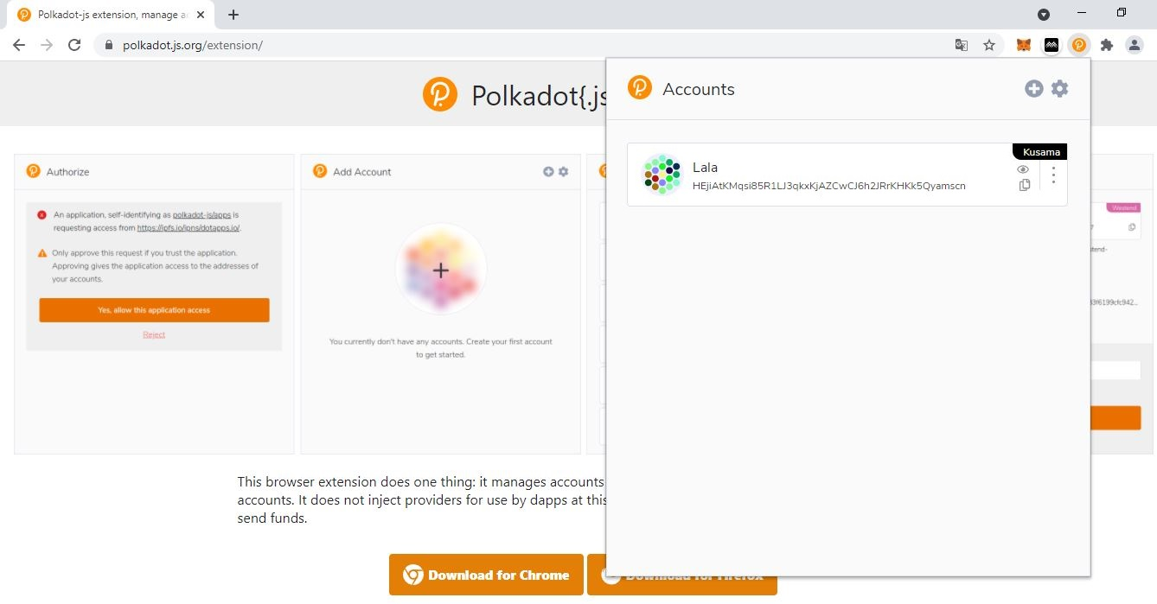

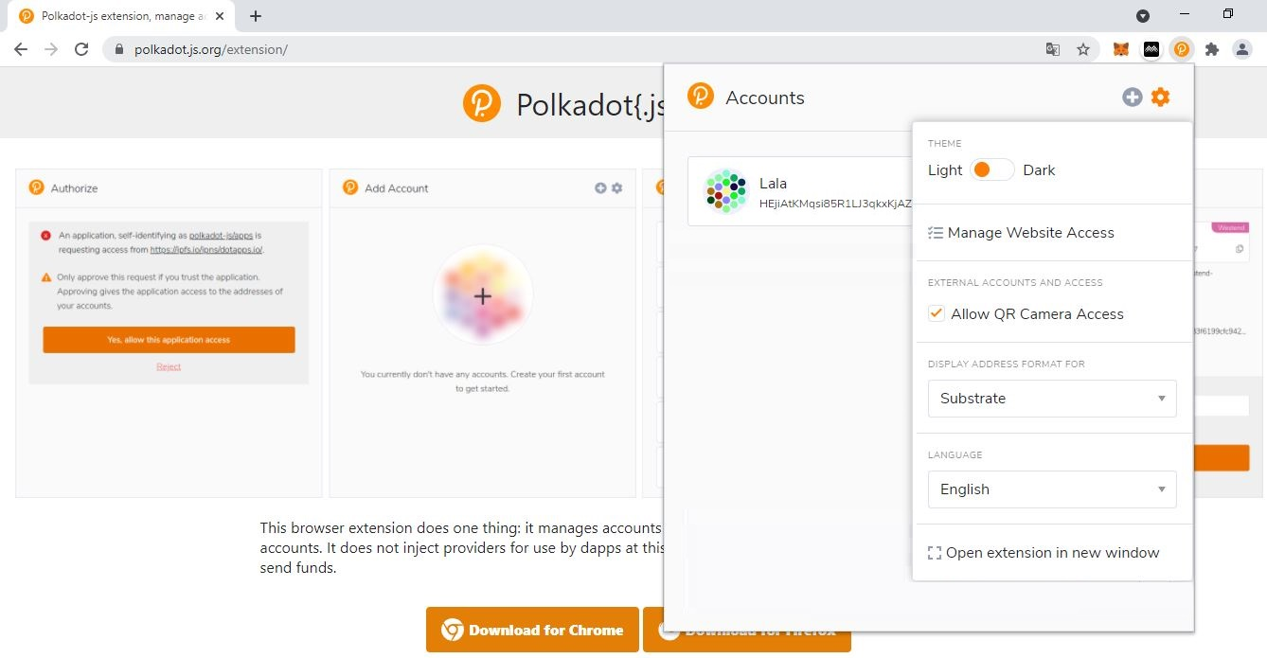

2. Toggle the **theme button** to use Light/Dark mode.

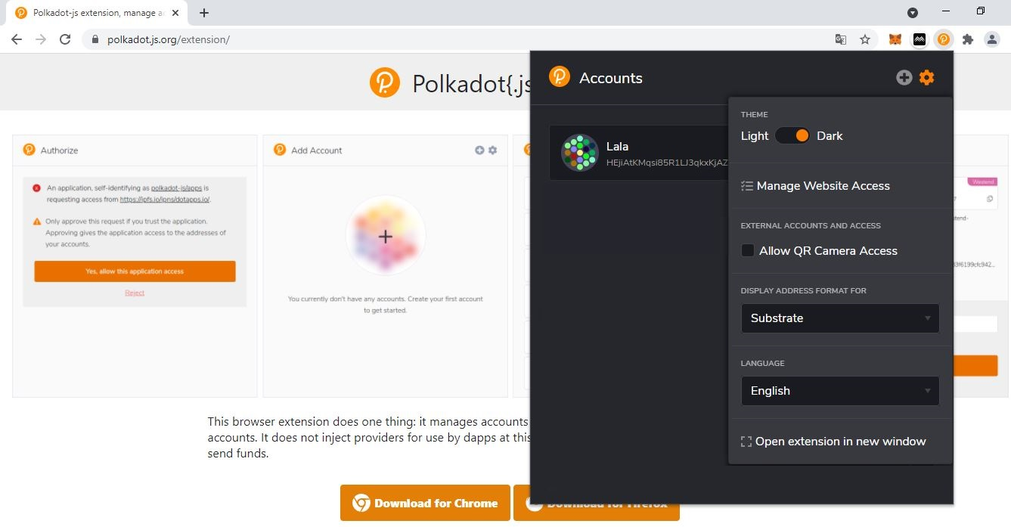

4. Click **Manage Website Access** to view third-party connections.

3. **Your Polkadot-JS extension is now using Dark mode!**

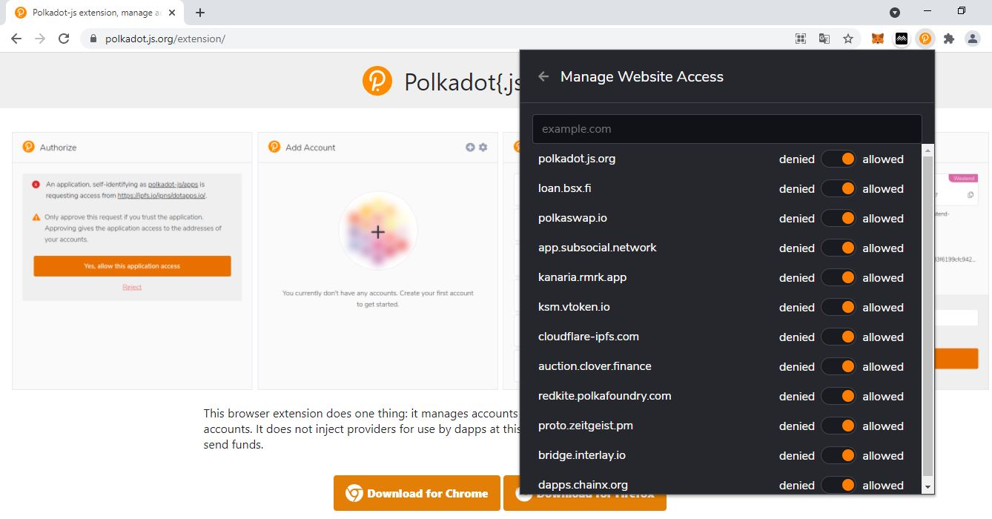

5. Toggle the **access button** to allow/deny website connections.

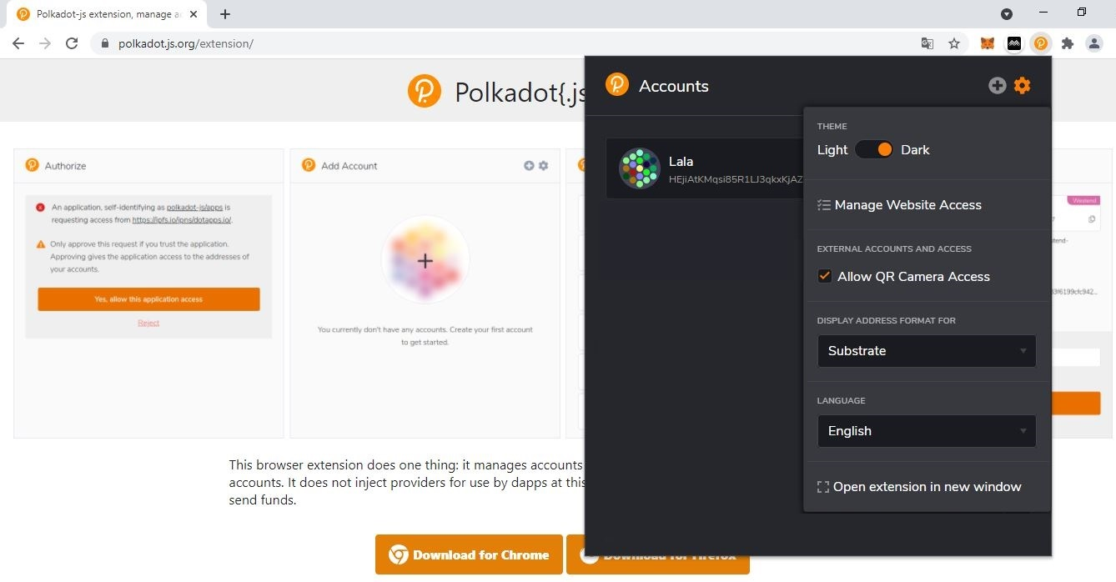

6. Tick the **Allow QR Camera Access** to enable QR operations.

7. Click the **dropdown menu** to change the default address format.

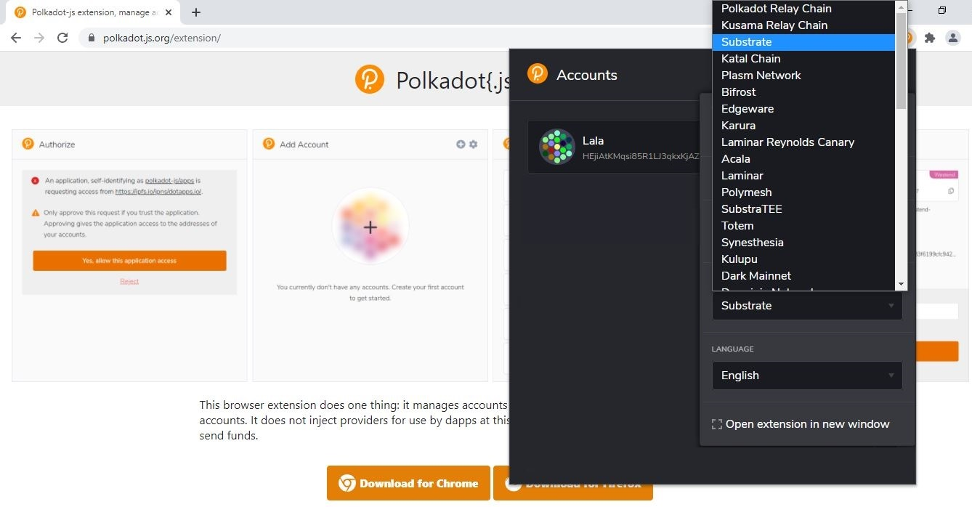

9. Click the **dropdown menu** to change the default language.

8. Select **one** address format to be applied on **all accounts that do not have an assigned network**.

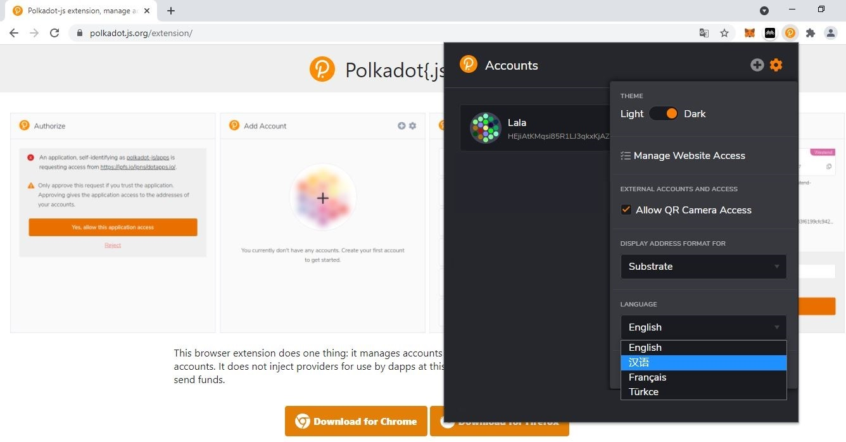

10. Select **one** language.

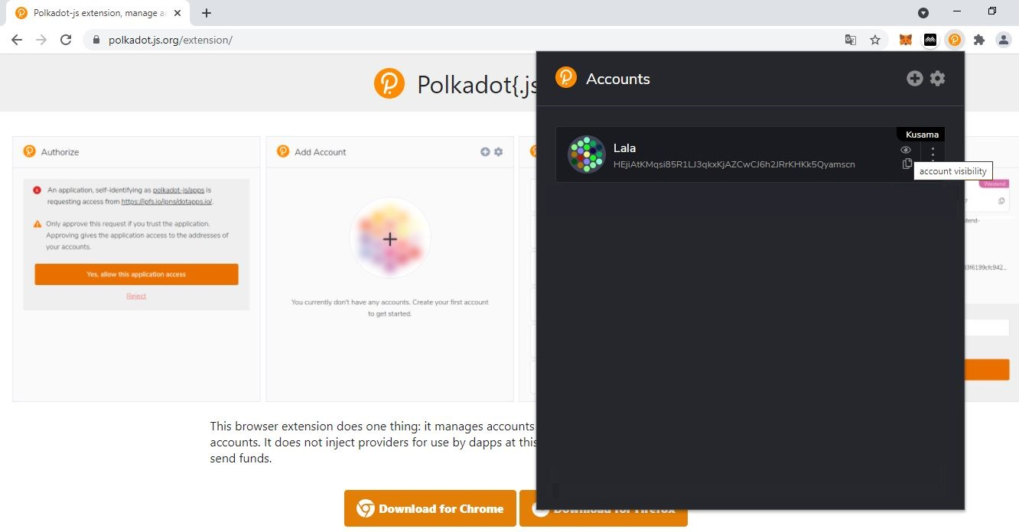

11. Click the **eye icon** to change an account’s visibility.

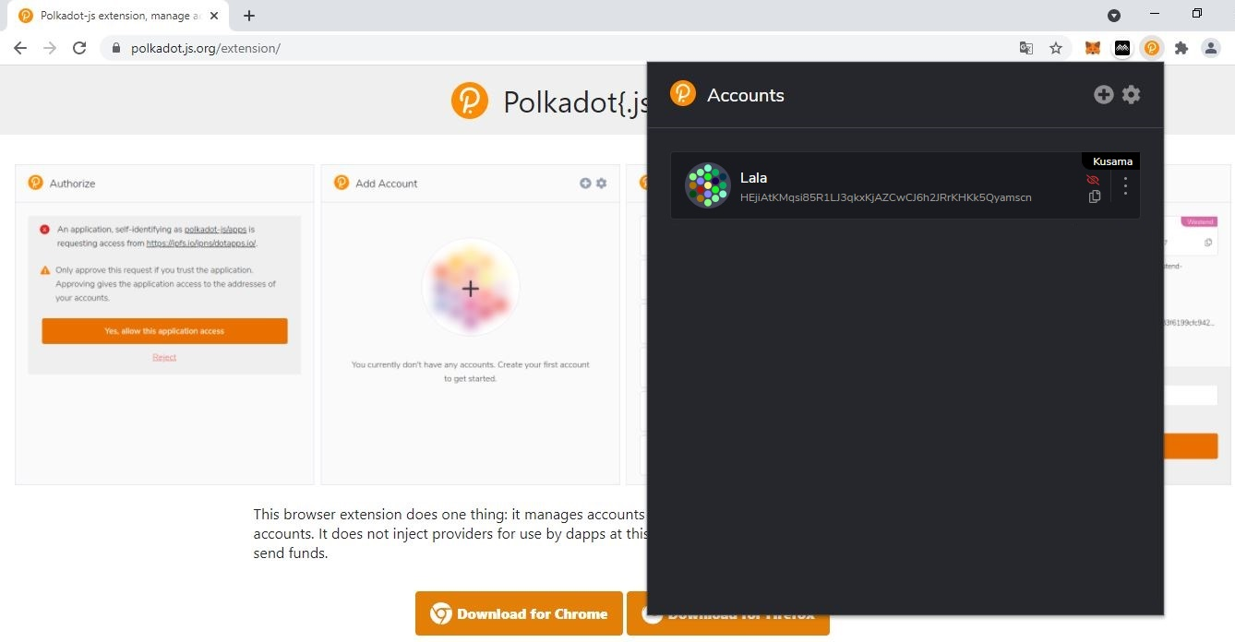

12. **Your account is now invisible and will not appear on *Polkadot-JS Apps*!**

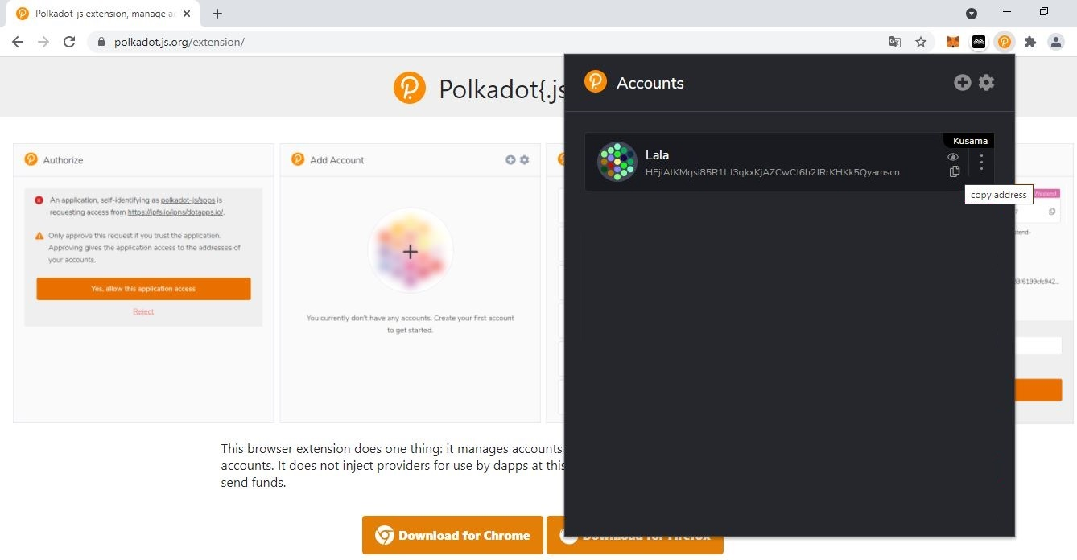

13. Click the **document icon** to copy your account address and submit it to receive KSM.